WHAT HAPPENS TO DEAD PLANTS AND ANIMALS?

Decomposition

ELEMENTARY SCHOOL UNIT

STUDENT PAGES

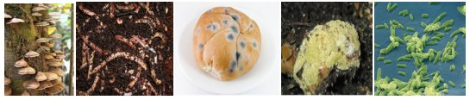

March 2009

Michigan State University

Environmental Literacy Project

Lindsey Mohan, Ed Smith, and Andy Anderson

Name: __________________________________________ Date: _____________

Exploring Ecosystems

Scientists study living organisms in ecosystems by constructing food chains and food webs. Food chains show how different living things are connected to one another.

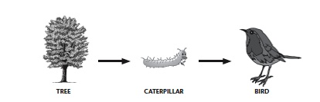
Here is an example of a food chain:

This food chain tells you that the caterpillar eats part of the tree, and that the bird eats the caterpillar. But this is not all that food chains can tell you!

Your teacher will give you a set of cards with images of different plants and animals. Working with your group, try to construct different food chains using the cards. You will need to think about what the organism eats in order to decide where the organism fits in the food chain. Record your food chains below, like the example in row 1.

Possible Food Chains:
# | List food Chain Here
1 | Tree → Caterpillar → Bird
2

3

4

5

6

7

Initial Ideas about Ecosystems
- What does a food chains tell you? What is represented by the arrows? ___________
________________________________________________________________________________________________________________________________________________________________________________________________________________________________________________________________________________________

2. Animals that eat producers are called “primary consumers” or “herbivores”. Animals that eat primary consumers are called “secondary consumers” or “carnivores”. Look at the chart your class constructed. List the different type of animals in the table below.

Producers | Herbivores | Carnivores

3. Do you think anything is missing from your ecosystem chart? ___________________
__________________________________________________________________________________________________________________________________________________________________________________________________________________

Name:_____________________________________ Date: ____________

What Happens to Dead Plants and Animals?

In the Fall, many leaves fall of the trees and pile up on the ground. Most of these leaves are gone by summer. What happens to the materials that make up the leaves?

Now that your class has talk about your ideas, do you have anything new or different to add to what you wrote above?
Name:_____________________________________ Date: ____________

Observations of Mold

Mass Observations:

Start Mass: ____________
End Mass: _____________
Difference: _____________

Descriptive Observations:

Describe and draw as completely as possible what you see happening to the pumpkin.

Describe and draw as completely as possible what you see happening to the mold.

QUESTIONS:

- The mold uses the pumpkin materials for two things. Use the process tool to show what two things may happen to the matter and energy as the mold eats the pumpkin

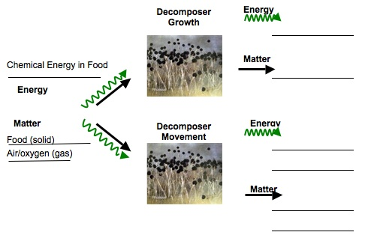

2. If someone said the stuff that makes up the pumpkin eventually turns into gases in the air, would you agree? Why or why not? ___________________________________
__________________________________________________________________________________________________________________________________________________________________________________________________________________
Name:_______________________________________ Date: _____________

Bananas and Yeast

Directions for Setting-Up Your Experiment

- Each group will need to obtain the materials from your teacher. You will need 4 pieces of banana, 4 plastic containers with caps, and 1 packet of yeast. Do not open your packet of yeast. It is important that the yeast not be open until Step 3 so that you do not contaminate all the banana pieces.

- Place one piece of banana in each of the four containers. Place a cap on two of the containers, but leave two open. Label the two closed containers. In order to label the containers, place a piece of tape on each container and use a marker to label each piece of tape. One container will need to be labeled “No Yeast, Cold” and the other container will need to be labeled “No Yeast, Warm”

- Open the packet of yeast. Sprinkle a small amount of yeast into the two open containers. You will only need to sprinkle about 20 yeasts into each container. Then seal the two containers. Now label these containers as “Yeast, Cold” and “Yeast, Warm”

- Make sure to write your names somewhere on the labels.

- Place the containers in the cold and warm areas designated by your teacher.

Predictions: Write predictions for what you think will happen to the yeast and the banana in each of the four conditions. Make sure to explain your ideas as much as possible.

Prediction: “No Yeast, Cold: ______________________________________________
______________________________________________________________________

Prediction: No Yeast, Warm: ______________________________________________
______________________________________________________________________

Prediction: Yeast, Cold: __________________________________________________
______________________________________________________________________

Prediction: Yeast, Warm: _________________________________________________
______________________________________________________________________
Name:_______________________________________ Date: ____________

Observing Bananas and Yeast

Several days ago your group set-up an investigation to watch what happens to bananas when yeast is added to them. Now it’s time to see what happened! When you observe your bananas and yeast, make careful observations of what happened to both the bananas and the yeast in each of your four conditions. Describe as completely as possible what you see.

Condition 1: No Yeast, Cold:
Condition 2: Yeast, Cold:
Condition 3: No Yeast, Warm:
Condition 4: Yeast, Warm:
Now’s, let’s see if your group got similar results as the other groups in the class. After your class combines their experiments, make observations of all the bananas and yeast in each condition.

What are some general observations can you make about each group?

Reflections Questions: In your group discuss the following questions.

- How are the bananas and the yeast changing in size and shape? _______________
_________________________________________________________________________________________________________________________________________________________________________________________________________
- The bananas are changing and losing weight. Where do you think the materials that make up the banana are going? _________________________________________
_________________________________________________________________________________________________________________________________________________________________________________________________________
- The yeast is growing. Where do you think the new material comes from? _________
_________________________________________________________________________________________________________________________________________________________________________________________________________
- Do yeast need chemical energy and air like other organisms? __________________
_________________________________________________________________________________________________________________________________________________________________________________________________________

Name: ________________________________________ Date: _____________

What Do Food Chains Tell Us?

The food chain shows a rabbit eating grass, and a wolf
eating a rabbit. What do the arrows tell us about the
matter and energy that moves between the organisms?

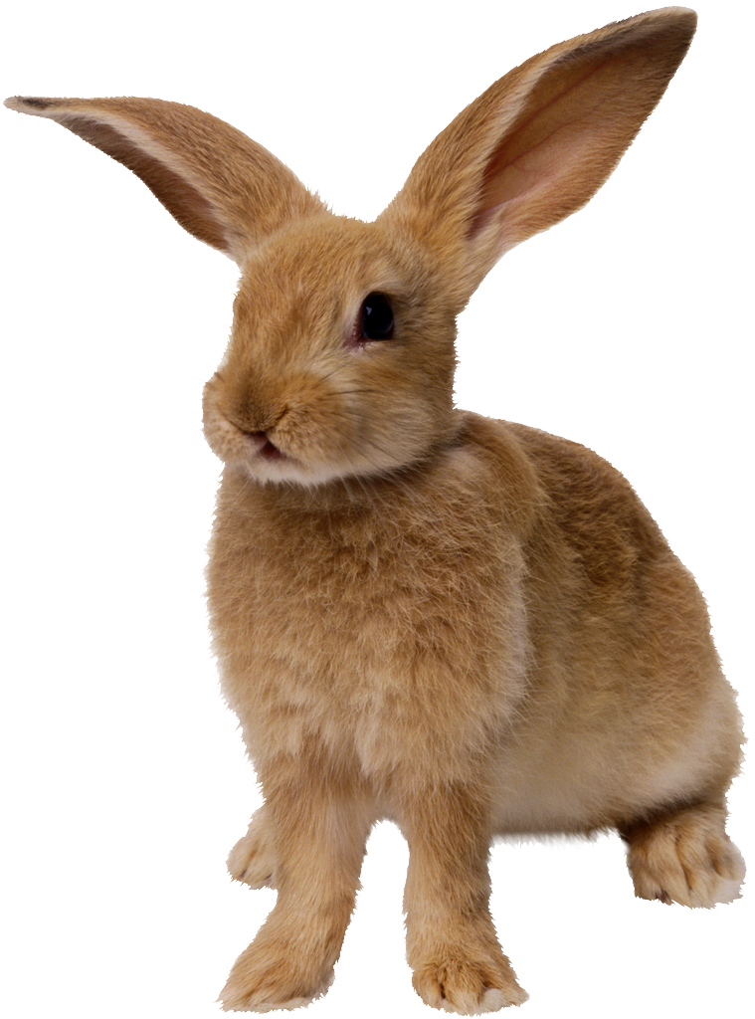
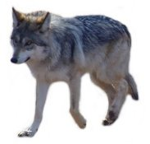
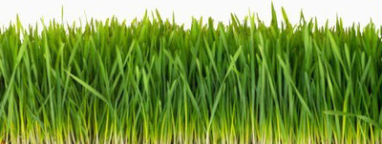
Practice: First, think about the grass. How does the grass change matter and energy? Use the process tool to show how grass makes its food.

Grass Growing

Energy
Energy

Matter
Matter

Grass will use some of the food it makes to keep its cells functioning, and when it uses this food, it gives off gases into the air. But a lot of the materials plants make stay stored in their body structure, like blades of grass, or branches on trees. This stored material is what becomes food for the rabbit in the food chain. On the next page, show how matter and energy change when the rabbit eats the grass.
Remember there are two things that can happen to food when the rabbit eats grass. The food can be used to grow or the food can be used to move.
Rabbit Eats Grass and Uses it to Grow
Chemical Energy in Grass
Grass (solid)
Air/oxygen (gas)
Rabbit Eats Grass and Uses it to Move
Matter
Matter
Energy
Energy
Energy
Matter

The food the rabbit eats and uses to move will become part of the air in the atmosphere, so the wolf is not able to have those materials. When the wolf eats the rabbit, it only gets the materials the rabbit stored in its body to grow. On the next page, use the process tool to show what happens to matter and energy when the wolf eats the rabbit.

Remember there are two things that can happen to food when the wolf eats rabbit. The food can be used to grow or the food can be used to move.

Matter
Matter
Energy
Energy
Energy
Matter
Wolf Eats Rabbit and Uses it to Grow
Chemical Energy in Grass
Rabbit body structure (solid)
Air/oxygen (gas)
Wolf Eats Rabbit and Uses it to Move

